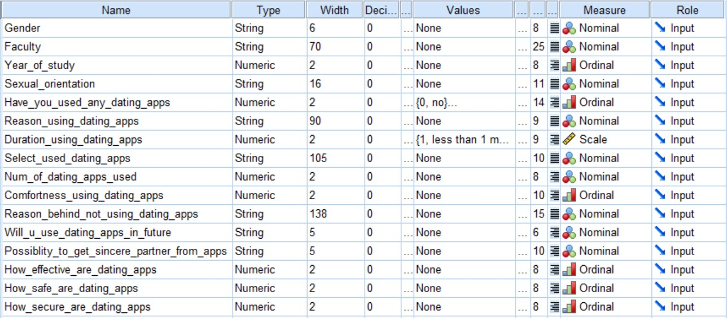

**Hypotheses**

1. **H0 :** The number of students using dating apps are only 29% of the population. ([YouGov](https://my.yougov.com/en-my/news/2017/11/23/internet-dating/), 2017) (Q5)

**HA :** The number of students using dating apps are less than 29% of the population.

Dependent variable: have you used any dating apps (yes/no)

Factor: -

(can be just descriptive)Calculate the number of students using dating apps / all students

|  |  |  |  |  |  |  |
| --- | --- | --- | --- | --- | --- | --- |
| **Descriptive Statistics** | | | | | | |
|  | N | Minimum | Maximum | Mean | Std. Deviation | Variance |
| Have you used any dating app(s)? | 108 | 0 | 1 | .22 | .418 | .174 |
| Valid N (listwise) | 108 |  |  |  |  |  |

The one sample *t*-test has four main assumptions:

• The dependent variable must be continuous (interval/ratio).

• The observations are independent of one another.

• The dependent variable should be approximately normally distributed. (normality test)

• The dependent variable should not contain any outliers.

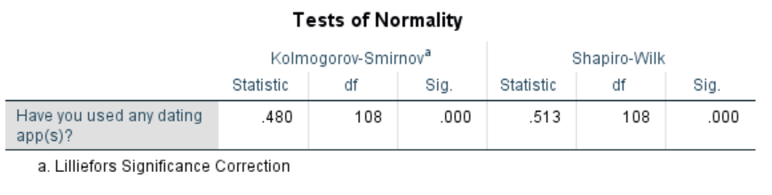

Null hypothesis for normality: The data is normally distributed.

Alternative hypothesis for normality: The data is not normally distributed.

From the Shapiro-Wilk test, the p-value(2.7985E-17) is less than 0.05, the data significantly deviate from a normal distribution.

Thus, one sample T-test is not appropriate to be used.

(I still test it even though the assumption is not met)

|  |  |  |  |  |
| --- | --- | --- | --- | --- |
| **One-Sample Statistics** | | | | |
|  | N | Mean | Std. Deviation | Std. Error Mean |
| Have you used any dating app(s)? | 108 | .22 | .418 | .040 |

|  |  |  |  |  |  |  |
| --- | --- | --- | --- | --- | --- | --- |
| **One-Sample Test** | | | | | | |
|  | Test Value = 0.29 | | | | | |
| t | df | Sig. (2-tailed) | Mean Difference | 95% Confidence Interval of the Difference | |
| Lower | Upper |
| Have you used any dating app(s)? | -1.686 | 107 | .095 | -.068 | -.15 | .01 |

I use one sample sign test(signed test) and Wilcoxon Sign-ranked test as the non-parametric tests for this hypothesis.

Chi square test is not used as it needs at least two categorical variables.

<https://www.quality-control-plan.com/StatGuide/ttest_one_alts.htm#Nonparametric%20tests>

|  |  |  |  |  |  |
| --- | --- | --- | --- | --- | --- |
| **Descriptive Statistics** | | | | | |
|  | N | Mean | Std. Deviation | Minimum | Maximum |
| (self-created to compare with the total students using dating apps) | 108 | .2900 | .00000 | .29 | .29 |
| Have you used any dating app(s)? | 108 | .22 | .418 | 0 | 1 |

**Wilcoxon Signed Ranks Test**

|  |  |  |  |  |
| --- | --- | --- | --- | --- |
| **Ranks** | | | | |
|  | | N | Mean Rank | Sum of Ranks |
| Have you used any dating app(s)? - (self-created to compare with the total students using dating apps) | Negative Ranks | 84a | 42.50 | 3570.00 |
| Positive Ranks | 24b | 96.50 | 2316.00 |
| Ties | 0c |  |  |
| Total | 108 |  |  |
| a. Have you used any dating app(s)? < (self-created to compare with the total students using dating apps) | | | | |
| b. Have you used any dating app(s)? > (self-created to compare with the total students using dating apps) | | | | |
| c. Have you used any dating app(s)? = (self-created to compare with the total students using dating apps) | | | | |

|  |  |
| --- | --- |
| **Test Statisticsa** | |
|  | Have you used any dating app(s)? - (self-created to compare with the total students using dating apps) |
| Z | -2.047b |
| Asymp. Sig. (2-tailed) | .041 |
| a. Wilcoxon Signed Ranks Test | |
| b. Based on positive ranks. | |

**Sign Test**

|  |  |  |
| --- | --- | --- |
| **Frequencies** | | |
|  | | N |
| Have you used any dating app(s)? - (self-created to compare with the total students using dating apps) | Negative Differencesa | 84 |
| Positive Differencesb | 24 |
| Tiesc | 0 |
| Total | 108 |
| a. Have you used any dating app(s)? < (self-created to compare with the total students using dating apps) | | |
| b. Have you used any dating app(s)? > (self-created to compare with the total students using dating apps) | | |
| c. Have you used any dating app(s)? = (self-created to compare with the total students using dating apps) | | |

|  |  |
| --- | --- |
| **Test Statisticsa** | |
|  | Have you used any dating app(s)? - (self-created to compare with the total students using dating apps) |
| Z | -5.677 |
| Asymp. Sig. (2-tailed) | .000 |
| a. Sign Test | |

Discussion:

A sign test was used to compare the differences in the amount of students using dating apps with the value obtained from YouGov, which is 29%. The p-value obtained (1.3686E-8) is smaller than 0.05, thus the test is statistically significant. We reject the null hypothesis. And the alternative hypothesis is accepted in this case as there are 22% of students using dating apps based on the data set.

1. **H0 :** There is no significant difference between usage of dating apps between men and women among undergraduate students in UM.

**HA :** There is significant difference between usage of dating apps between men and women among undergraduate students in UM.

Dependent variable:

Factor:

I use chi square test as the non-parametric test for this hypothesis.

|  |  |  |  |  |  |
| --- | --- | --- | --- | --- | --- |
| **Have you used any dating app(s)? * What is your gender? Crosstabulation** | | | | | |
|  | | | What is your gender? | | Total |
| Female | Male |
| Have you used any dating app(s)? | no | Count | 53 | 31 | 84 |
| % within Have you used any dating app(s)? | 63.1% | 36.9% | 100.0% |
| % within What is your gender? | 84.1% | 68.9% | 77.8% |
| % of Total | 49.1% | 28.7% | 77.8% |
| yes | Count | 10 | 14 | 24 |
| % within Have you used any dating app(s)? | 41.7% | 58.3% | 100.0% |
| % within What is your gender? | 15.9% | 31.1% | 22.2% |
| % of Total | 9.3% | 13.0% | 22.2% |
| Total | | Count | 63 | 45 | 108 |
| % within Have you used any dating app(s)? | 58.3% | 41.7% | 100.0% |
| % within What is your gender? | 100.0% | 100.0% | 100.0% |
| % of Total | 58.3% | 41.7% | 100.0% |

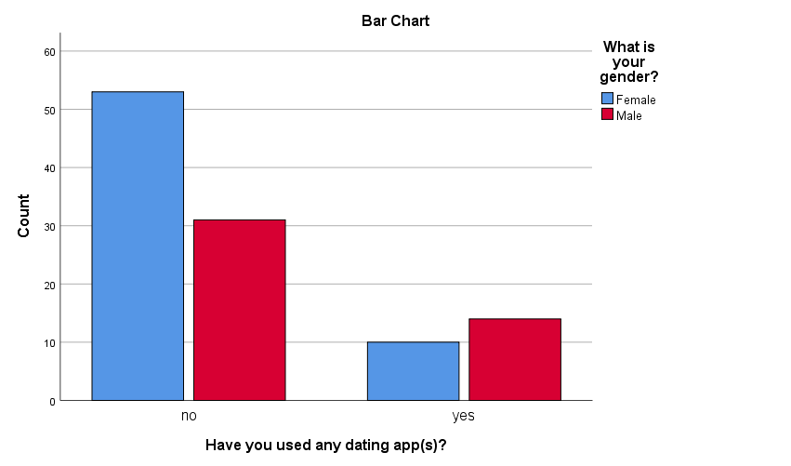

Bar chart for hypothesis 2

|  |  |  |  |  |  |
| --- | --- | --- | --- | --- | --- |
| **Chi-Square Tests** | | | | | |
|  | Value | df | Asymptotic Significance (2-sided) | Exact Sig. (2-sided) | Exact Sig. (1-sided) |
| Pearson Chi-Square | 3.527a | 1 | .060 |  |  |
| Continuity Correctionb | 2.700 | 1 | .100 |  |  |
| Likelihood Ratio | 3.485 | 1 | .062 |  |  |
| Fisher's Exact Test |  |  |  | .099 | .051 |
| N of Valid Cases | 108 |  |  |  |  |
| a. 0 cells (0.0%) have expected count less than 5. The minimum expected count is 10.00. | | | | | |
| b. Computed only for a 2x2 table | | | | | |

Discussion:

From the bar chart for hypothesis 2, we can see that there is an obvious different in number of the male and female students who do not use dating apps. The difference in number of male and female students who are using dating apps are rather little.

The value of the Pearson Chi-Square test is 3.527, with degree of freedom = 1. The p-value of this test is 0.060, which is more than 0.05. Thus, we do not reject the null hypothesis. Rather, we conclude that there is not enough evidence to suggest an association between gender and the usage of dating apps.

Based on the results, we can state the following:

No association was found between gender and usage of dating apps. (X2(1) > = 3.527, p = 0.060).

1. **H0 :** There is no significant difference between heterosexuals and non heterosexuals in using dating apps.

**HA :** There is significant difference between heterosexuals and non heterosexuals in using dating apps.

Dependent variable: Usage on dating apps

Factor: sexual orientation

Same, I used chi square test as the non-parametric test for this hypothesis. I also performed Mann Whitney U test (bcz ordinal scale is used)

Assumptions of the Mann-Whitney test:

* random samples from populations
* independence within samples and mutual independence between samples
* measurement scale is at least ordinal

|  |  |  |  |
| --- | --- | --- | --- |
| **Descriptive Statistics** | | | |
| Have you used any dating app(s)? | | | |
| Heterosexual | N | Valid | 90 |
| Missing | 0 |
| Mean | | .17 |
| Median | | .00 |
| Skewness | | 1.819 |
| Std. Error of Skewness | | .254 |
| Kurtosis | | 1.339 |
| Std. Error of Kurtosis | | .503 |
| Non-Heterosexual | N | Valid | 18 |
| Missing | 0 |
| Mean | | .50 |
| Median | | .50 |
| Skewness | | .000 |
| Std. Error of Skewness | | .536 |
| Kurtosis | | -2.267 |
| Std. Error of Kurtosis | | 1.038 |

|  |  |  |  |  |  |  |
| --- | --- | --- | --- | --- | --- | --- |
| **Have you used any dating app(s)?** | | | | | | |
| What is your sexual orientation? | | | Frequency | Percent | Valid Percent | Cumulative Percent |
| Heterosexual | Valid | no | 75 | 83.3 | 83.3 | 83.3 |
| yes | 15 | 16.7 | 16.7 | 100.0 |
| Total | 90 | 100.0 | 100.0 |  |
| Non-Heterosexual | Valid | no | 9 | 50.0 | 50.0 | 50.0 |
| yes | 9 | 50.0 | 50.0 | 100.0 |
| Total | 18 | 100.0 | 100.0 |  |

**Chi Square test**

|  |  |  |  |  |  |  |
| --- | --- | --- | --- | --- | --- | --- |
| **Case Processing Summary** | | | | | | |
|  | Cases | | | | | |
| Valid | | Missing | | Total | |
| N | Percent | N | Percent | N | Percent |
| Have you used any dating app(s)? * What is your sexual orientation? | 108 | 100.0% | 0 | 0.0% | 108 | 100.0% |

|  |  |  |  |  |  |
| --- | --- | --- | --- | --- | --- |
| **Have you used any dating app(s)? * What is your sexual orientation? Crosstabulation** | | | | | |
|  | | | What is your sexual orientation? | | Total |
| Heterosexual | Non-Heterosexual |
| Have you used any dating app(s)? | no | Count | 75 | 9 | 84 |
| % within Have you used any dating app(s)? | 89.3% | 10.7% | 100.0% |
| % within What is your sexual orientation? | 83.3% | 50.0% | 77.8% |
| % of Total | 69.4% | 8.3% | 77.8% |
| yes | Count | 15 | 9 | 24 |
| % within Have you used any dating app(s)? | 62.5% | 37.5% | 100.0% |
| % within What is your sexual orientation? | 16.7% | 50.0% | 22.2% |
| % of Total | 13.9% | 8.3% | 22.2% |
| Total | | Count | 90 | 18 | 108 |
| % within Have you used any dating app(s)? | 83.3% | 16.7% | 100.0% |
| % within What is your sexual orientation? | 100.0% | 100.0% | 100.0% |
| % of Total | 83.3% | 16.7% | 100.0% |

|  |  |  |  |  |  |
| --- | --- | --- | --- | --- | --- |
| **Chi-Square Tests** | | | | | |
|  | Value | df | Asymptotic Significance (2-sided) | Exact Sig. (2-sided) | Exact Sig. (1-sided) |
| Pearson Chi-Square | 9.643a | 1 | **.002** |  |  |
| Continuity Correctionb | 7.811 | 1 | .005 |  |  |
| Likelihood Ratio | 8.362 | 1 | .004 |  |  |
| Fisher's Exact Test |  |  |  | .004 | .004 |
| N of Valid Cases | 108 |  |  |  |  |
| a. 1 cells (25.0%) have expected count less than 5. The minimum expected count is 4.00. | | | | | |
| b. Computed only for a 2x2 table | | | | | |

|  |  |  |  |  |  |
| --- | --- | --- | --- | --- | --- |
| **Symmetric Measuresc** | | | | | |
|  | | Value | Asymptotic Standard Errora | Approximate Tb | Approximate Significance |
| Nominal by Nominal | Phi | .299 |  |  | .002 |
| Cramer's V | .299 |  |  | .002 |
| Ordinal by Ordinal | Kendall's tau-b | .299 | .111 | 2.436 | .015 |
| N of Valid Cases | | 108 |  |  |  |
| a. Not assuming the null hypothesis. | | | | | |
| b. Using the asymptotic standard error assuming the null hypothesis. | | | | | |
| c. Correlation statistics are available for numeric data only. | | | | | |

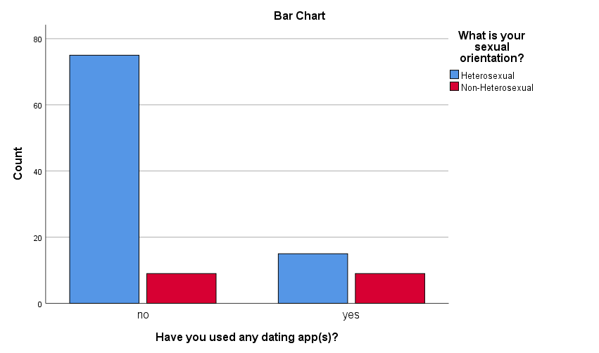

**Test for Homogeneity of Variance**

|  |  |  |  |  |  |
| --- | --- | --- | --- | --- | --- |
| **Test of Homogeneity of Variance** | | | | | |
|  | | Levene Statistic | df1 | df2 | Sig. |
| Have you used any dating app(s)? | Based on Mean | 14.133 | 1 | 106 | .000 |
| Based on Median | **14.133** | 1 | 106 | .000 |
| Based on Median and with adjusted df | **14.133** | 1 | 89.000 | .000 |
| Based on trimmed mean | 14.133 | 1 | 106 | .000 |

**Mann-Whitney Test**

|  |  |  |  |  |
| --- | --- | --- | --- | --- |
| **Ranks** | | | | |
|  | 1 Het; 2 Nhet (for Mann-Whitney u test) | N | Mean Rank | Sum of Ranks |
| Have you used any dating app(s)? | 1.00 | 90 | 51.50 | 4635.00 |
| 2.00 | 18 | 69.50 | 1251.00 |
| Total | 108 |  |  |

|  |  |
| --- | --- |
| **Test Statisticsa** | |
|  | Have you used any dating app(s)? |
| Mann-Whitney U | 540.000 |
| Wilcoxon W | 4635.000 |
| Z | -3.091 |
| Asymp. Sig. (2-tailed) | .002 |
| a. Grouping Variable: 1 Het; 2 Nhet (for Mann-Whitney u test) | |

**The 1.00 refers to heterosexual, the 2.00 refers to non-heterosexual

Discussion:

The p-value from the chi-square test is smaller than 0.05, we reject the null hypothesis. There is statistical significance between the sexual orientation on the usage of dating app.

By performing the test for homogeneity of variance, we obtained the values of Levene statistic for “based on median” and “based on median and with adjusted df” are both the same(14.133). The p-value(0.000304) is smaller than 0.05, thus we can say that the variances for heterosexual and non-heterosexual are not homogenous. Implicitly we assume that the data distribution for two groups are not homogenous. In this case, we only can compare the mean ranks if we conduct Mann-Whitney U test.

From the mean rank of Mann-Whitney U test, there is an obvious difference between heterosexual and non-heterosexual who use the dating app. We don’t know if it is statistically significant because it is not normally distributed. The z-value(-3.091) is far from 0, and the p-value(0.002), which is less than 0.05, thus we reject the null hypothesis. as there is significant difference between non-heterosexual and heterosexual in the usage of dating apps.

Reason: The very unequal number of heterosexual and non-heterosexual respondents.

???Some website said that Mann-Whitney and Kruskal-Wallis test are for data that have larger range.

???In this case, the data distribution are not similar for heterosexual and non-heterosexual, so it is not recommended to use Mann-Whitney and Kruskal-Wallis test

1. **H0 :** There is no significant difference between gender on the effectiveness of dating apps.

**HA :** There is significant difference between gender on the effectiveness of dating apps.

Dependent variable: Effectiveness of dating apps

Factor: Gender

Is effectiveness of dating apps a scale variable or ordinal variable?

As scale variable:

**Normality test**

|  |  |  |  |  |  |
| --- | --- | --- | --- | --- | --- |
| **Descriptives** | | | | | |
|  | What is your gender? | | | Statistic | Std. Error |
| In your opinion, how effective are dating apps? | Female | Mean | | **2.73** | .126 |
| 95% Confidence Interval for Mean | Lower Bound | 2.48 |  |
| Upper Bound | 2.98 |  |
| 5% Trimmed Mean | | 2.72 |  |
| Median | | **3.00** |  |
| Variance | | 1.007 |  |
| Std. Deviation | | **1.003** |  |
| Minimum | | 1 |  |
| Maximum | | 5 |  |
| Range | | 4 |  |
| Interquartile Range | | 1 |  |
| Skewness | | **-.218** | .302 |
| Kurtosis | | **-.186** | .595 |
| Male | Mean | | **2.69** | .142 |
| 95% Confidence Interval for Mean | Lower Bound | 2.40 |  |
| Upper Bound | 2.97 |  |
| 5% Trimmed Mean | | 2.71 |  |
| Median | | **3.00** |  |
| Variance | | .901 |  |
| Std. Deviation | | **.949** |  |
| Minimum | | 1 |  |
| Maximum | | 4 |  |
| Range | | 3 |  |
| Interquartile Range | | 1 |  |
| Skewness | | **-.491** | .354 |
| Kurtosis | | **-.566** | .695 |

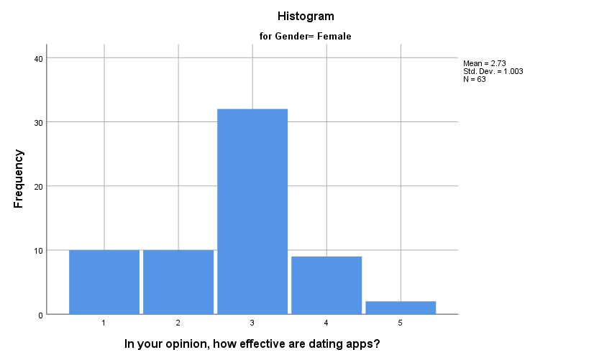

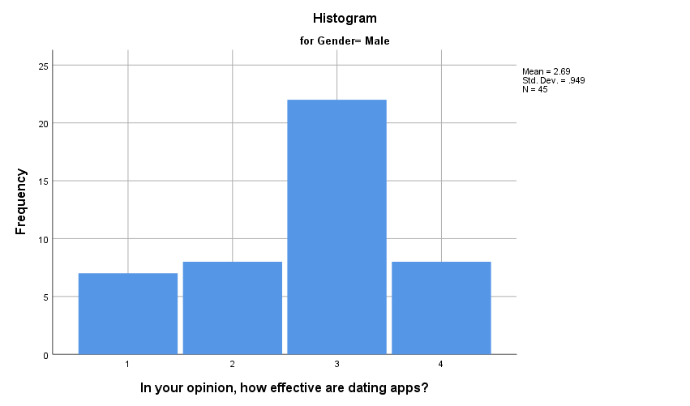

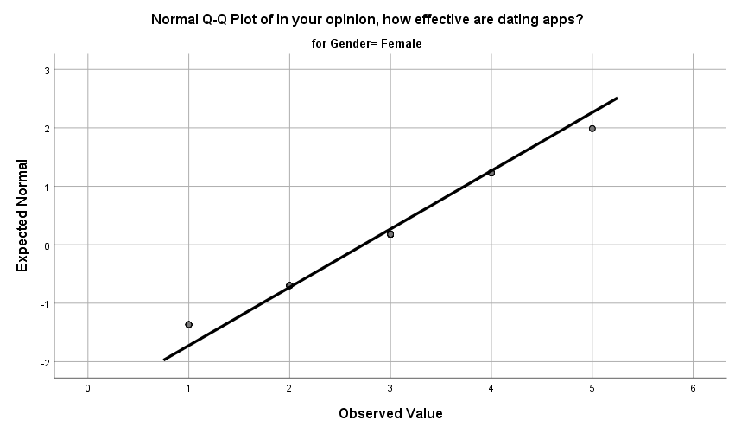

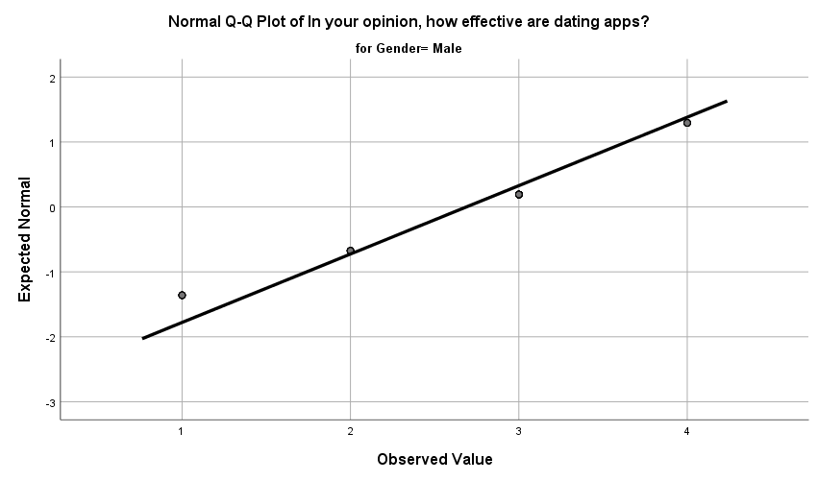

|  |  |  |  |  |  |  |  |
| --- | --- | --- | --- | --- | --- | --- | --- |
| **Tests of Normality** | | | | | | | |
|  | What is your gender? | Kolmogorov-Smirnova | | | Shapiro-Wilk | | |
|  | Statistic | df | Sig. | Statistic | df | Sig. |
| In your opinion, how effective are dating apps? | Female | .289 | 63 | .000 | .870 | 63 | .000 |
| Male | .295 | 45 | .000 | .846 | 45 | .000 |
| a. Lilliefors Significance Correction | | | | | | | |

**Mann-Whitney test**

|  |
| --- |
|  |

|  |  |  |  |  |
| --- | --- | --- | --- | --- |
| **Ranks** | | | | |
|  | 1-Male; 2-Female | N | Mean Rank | Sum of Ranks |
| In your opinion, how effective are dating apps? | 1 | 45 | 54.09 | 2434.00 |
| 2 | 63 | 54.79 | 3452.00 |
| Total | 108 |  |  |

|  |  |
| --- | --- |
| **Test Statisticsa** | |
|  | In your opinion, how effective are dating apps? |
| Mann-Whitney U | 1399.000 |
| Wilcoxon W | 2434.000 |
| Z | -.124 |
| Asymp. Sig. (2-tailed) | .901 |
| a. Grouping Variable: 1-Male; 2-Female | |
|  | |

**Kruskal-Wallis H test (do the post hoc test for this)**

**Assumption #1:** Your **dependent variable** should be measured at the **ordinal** or **continuous level** (i.e., **interval** or **ratio**).

**Assumption #2:** Your **independent variable** should consist of **two or more categorical**, **independent groups**.

**Assumption #3:** You should have **independence of observations**, which means that there is no relationship between the observations in each group or between the groups themselves.

* **Assumption #4:** In order to know how to interpret the results from a Kruskal-Wallis H test, you have to determine whether the **distributions** in each group (i.e., the distribution of scores for each group of the independent variable) have the **same shape** (which also means the **same variability**).

(if distributions have the same shape > compare the medians of DV; if distirbutions have different shape > compare mean ranks)

Discussion:

Can do regression, correlation(spearmen, Kendal or pearson), try simple linear regression(ordinal regression)?

Set hypothesis for each test

By looking at the histogram from descriptive statistic, we can see that the data are not distributed normally. This can be further proven by the normality test (We do not used the visual method to examine the normality). The p-value of Shapiro-Wilk test for both male and female are less than 0.05, this statistically significant result indicates that the data are not normally distributed. Hence neither independent sample t-test nor one-way ANOVA test is used.

Instead, we are using Mann-Whitney U test and Kruskal-Wallis test to test the hypothesis. Both test perform similarly in this case.

<https://www.youtube.com/watch?v=oWARSC31Rno>

Before doing the two tests, we tested for the **homogeneity of variance** of the distribution of 2 group of data. (Using non-parametric way to test, include the Levene’s test but unlike the Levene’s test for normally distributed data)

|  |  |  |  |  |  |
| --- | --- | --- | --- | --- | --- |
| **ANOVA** | | | | | |
| abs_dif | | | | | |
|  | Sum of Squares | df | Mean Square | F | Sig. |
| Between Groups | 11.556 | 1 | 11.556 | .014 | .908 |
| Within Groups | 90535.462 | 106 | 854.108 |  |  |
| Total | 90547.018 | 107 |  |  |  |

From the ANOVA test above, we tested the homogeneity of variance, the p-value is 0.908, therefore we assume that the variance for two groups of data are roughly homogeneous (failed to reject the null hypothesis). The assumption of similar distributions between two group is applied.

I also used another way to test for the homogeneity of variance.

|  |  |  |  |  |  |
| --- | --- | --- | --- | --- | --- |
| **Test of Homogeneity of Variance** | | | | | |
|  | | Levene Statistic | df1 | df2 | Sig. |
| In your opinion, how effective are dating apps? | Based on Mean | .009 | 1 | 106 | .926 |
| Based on Median | .011 | 1 | 106 | .915 |
| Based on Median and with adjusted df | .011 | 1 | 105.710 | .915 |
| Based on trimmed mean | .034 | 1 | 106 | .855 |

Since it is non-parametric test, we do not focus on the mean. From the p-value of “based on median” and “based on median and with adjusted df” which are both 0.915, we can assume that there is no statistical significant different between the variances of two groups of data since it failed to reject the null hypothesis.

We are now going to examine the medians of two groups.

For the Mann-Whitney U test, the median for both groups are the same(3.00, can be seen from the descriptive statistic) and mean rank of male and female students are very closed to each other (despite of the inequality of respondents). The p-value(0.901) is greater than 0.05, thus the null hypothesis is not rejected. There is high possibility that there is no statistically significant difference between the gender on the effectiveness of dating apps. Most of the respondents think the dating apps are moderately effective in looking for partner.

**Kruskal-Wallis Test**

|  |  |  |  |
| --- | --- | --- | --- |
| **Ranks** | | | |
|  | 1-Male; 2-Female | N | Mean Rank |
| In your opinion, how effective are dating apps? | 1 | 45 | 54.09 |
| 2 | 63 | 54.79 |
| Total | 108 |  |

|  |  |
| --- | --- |
| **Test Statisticsa,b** | |
|  | In your opinion, how effective are dating apps? |
| Kruskal-Wallis H | .015 |
| df | 1 |
| Asymp. Sig. | .901 |
| a. Kruskal Wallis Test | |
| b. Grouping Variable: 1-Male; 2-Female | |

In Kruskal-Wallis test, we only examine the mean rank. The mean ranks for both groups are very similar, and the p-value is 0.901, higher than 0.05, which again tell us that the null hypothesis is not rejected.

Should I use chi-square or epsilon squared to get the effect size?

|  |  |  |  |
| --- | --- | --- | --- |
| **Chi-Square Tests** | | | |
|  | Value | df | Asymptotic Significance (2-sided) |
| Pearson Chi-Square | 1.710a | 4 | .789 |
| Likelihood Ratio | 2.435 | 4 | .656 |
| N of Valid Cases | 108 |  |  |
| a. 2 cells (20.0%) have expected count less than 5. The minimum expected count is .83. | | | |

|  |  |  |
| --- | --- | --- |
| **Measures of Association** | | |
|  | Eta | Eta Squared |
| Rank of How_effective_are_dating_apps * What is your gender? | .012 | .000 |

Using chi-square value to calculate the effect size, we got 0.01598130841121495327102803738318‬. Roughly only 1.6% of the variability in effectiveness of dating apps is accounted by the gender.

By calculating the epsilon squared effect size estimate based on Kruskal-Wallis test, we use the epsilon squared, we got 0.000144. (should I take Eta instead of Eta Squared?)

1. **H0 :** There is no significant difference between gender on the safeness of dating apps.

**HA :** There is significant difference between gender on the safeness of dating apps.

Dependent variable: Safeness of dating apps

Factor: Gender

Another hypothesis I have made

H0: The common number of dating app(s) used by students are 2.

HA: The number of dating app(s) used by students are more than 2. (1-tailed)

First, perform normality test

|  |  |  |  |  |  |  |
| --- | --- | --- | --- | --- | --- | --- |
| **Case Processing Summary** | | | | | | |
|  | Cases | | | | | |
| Valid | | Missing | | Total | |
| N | Percent | N | Percent | N | Percent |
| (self-created) from dating apps chosen, count the dating app used | 24 | 22.2% | 84 | 77.8% | 108 | 100.0% |

|  |  |  |  |  |
| --- | --- | --- | --- | --- |
| **Descriptives** | | | | |
|  | | | Statistic | Std. Error |
| (self-created) from dating apps chosen, count the dating app used | Mean | | 3.21 | .593 |
| 95% Confidence Interval for Mean | Lower Bound | 1.98 |  |
| Upper Bound | 4.43 |  |
| 5% Trimmed Mean | | 2.83 |  |
| Median | | 2.50 |  |
| Variance | | 8.433 |  |
| Std. Deviation | | 2.904 |  |
| Minimum | | 1 |  |
| Maximum | | 13 |  |
| Range | | 12 |  |
| Interquartile Range | | 4 |  |
| Skewness | | 1.924 | .472 |
| Kurtosis | | 4.588 | .918 |

|  |  |  |  |  |  |  |
| --- | --- | --- | --- | --- | --- | --- |
| **Tests of Normality** | | | | | | |
|  | Kolmogorov-Smirnova | | | Shapiro-Wilk | | |
| Statistic | df | Sig. | Statistic | df | Sig. |
| (self-created) from dating apps chosen, count the dating app used | .223 | 24 | .003 | .769 | 24 | .000 |
| a. Lilliefors Significance Correction | | | | | | |

From the Shapiro-Wilk test the p-value is smaller than 0.05, thus the test is statistical significant. The data are not distributed normally.

Cannot perform one-sample T test.

(I attach the result of one sample t test here although the assumption is violated)

|  |  |  |  |  |  |  |
| --- | --- | --- | --- | --- | --- | --- |
| **Case Processing Summary** | | | | | | |
|  | Cases | | | | | |
| Valid | | Missing | | Total | |
| N | Percent | N | Percent | N | Percent |
| (self-created) from dating apps chosen, count the dating app used | 24 | 22.2% | 84 | 77.8% | 108 | 100.0% |

|  |  |  |  |  |
| --- | --- | --- | --- | --- |
| **Descriptives** | | | | |
|  | | | Statistic | Std. Error |
| (self-created) from dating apps chosen, count the dating app used | Mean | | 3.21 | .593 |
| 95% Confidence Interval for Mean | Lower Bound | 1.98 |  |
| Upper Bound | 4.43 |  |
| 5% Trimmed Mean | | 2.83 |  |
| Median | | 2.50 |  |
| Variance | | 8.433 |  |
| Std. Deviation | | 2.904 |  |
| Minimum | | 1 |  |
| Maximum | | 13 |  |
| Range | | 12 |  |
| Interquartile Range | | 4 |  |
| Skewness | | 1.924 | .472 |
| Kurtosis | | 4.588 | .918 |

|  |  |  |  |  |  |  |
| --- | --- | --- | --- | --- | --- | --- |
| **Tests of Normality** | | | | | | |
|  | Kolmogorov-Smirnova | | | Shapiro-Wilk | | |
| Statistic | df | Sig. | Statistic | df | Sig. |
| (self-created) from dating apps chosen, count the dating app used | .223 | 24 | .003 | .769 | 24 | .000 |
| a. Lilliefors Significance Correction | | | | | | |

1-sample Wilcoxon Signed Rank Test

|  |  |  |  |  |  |
| --- | --- | --- | --- | --- | --- |
| **Descriptive Statistics** | | | | | |
|  | N | Mean | Std. Deviation | Minimum | Maximum |
| (self-created) from dating apps chosen, count the dating app used | 24 | 3.21 | 2.904 | 1 | 13 |
| (self-created, no data support) | 108 | 2.00 | .000 | 2 | 2 |

|  |  |  |  |  |
| --- | --- | --- | --- | --- |
| **Ranks** | | | | |
|  | | N | Mean Rank | Sum of Ranks |
| (self-created, no data support) - (self-created) from dating apps chosen, count the dating app used | Negative Ranks | 12a | 14.83 | 178.00 |
| Positive Ranks | 10b | 7.50 | 75.00 |
| Ties | 2c |  |  |
| Total | 24 |  |  |
| a. (self-created, no data support) < (self-created) from dating apps chosen, count the dating app used | | | | |
| b. (self-created, no data support) > (self-created) from dating apps chosen, count the dating app used | | | | |
| c. (self-created, no data support) = (self-created) from dating apps chosen, count the dating app used | | | | |

|  |  |
| --- | --- |
| **Test Statisticsa** | |
|  | (self-created, no data support) - (self-created) from dating apps chosen, count the dating app used |
| Z | -1.725b |
| Asymp. Sig. (2-tailed) | .085 |
| a. Wilcoxon Signed Ranks Test | |
| b. Based on positive ranks. | |

1-sample sign test

|  |  |  |
| --- | --- | --- |
| **Frequencies** | | |
|  | | N |
| (self-created, no data support) - (self-created) from dating apps chosen, count the dating app used | Negative Differencesa | 12 |
| Positive Differencesb | 10 |
| Tiesc | 2 |
| Total | 24 |
| a. (self-created, no data support) < (self-created) from dating apps chosen, count the dating app used | | |
| b. (self-created, no data support) > (self-created) from dating apps chosen, count the dating app used | | |
| c. (self-created, no data support) = (self-created) from dating apps chosen, count the dating app used | | |

|  |  |
| --- | --- |
| **Test Statisticsa** | |
|  | (self-created, no data support) - (self-created) from dating apps chosen, count the dating app used |
| Exact Sig. (2-tailed) | .832b |
| a. Sign Test | |
| b. Binomial distribution used. | |